23.53: a) 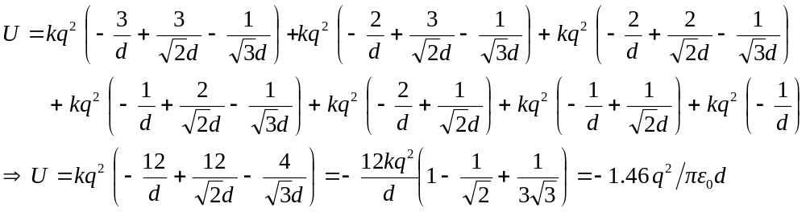

b) The fact that the electric potential energy is less than zero means that it is energetically favourable for the crystal ions to be together.

